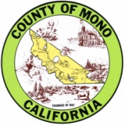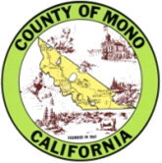**Community Flu Clinics 2018**

 **MONO COUNTY HEALTH DEPARTMENT**

**Cost for Flu vaccine:**

$10 for adults (19 yrs and older)

Medicare Part B free with card present

$5 for children (6mo -18 yrs)

Medicare parte “B”

**Flu vaccine is now recommended for everyone over the age of six months**

**ONLY INJECTABLE VACCINE IS AVAILABLE THIS YEAR**