WALKER WELLNESS CENTER The Wellness Center is OPEN TO EVERYONE in the community!!
FEBRUARY 2012 Please join us for FREE & FUN activities!
Sun | Mon | Tue | Wed | Thu | Fri | Sat
 |  |  |  |  | 1 | 2
 |  |  | 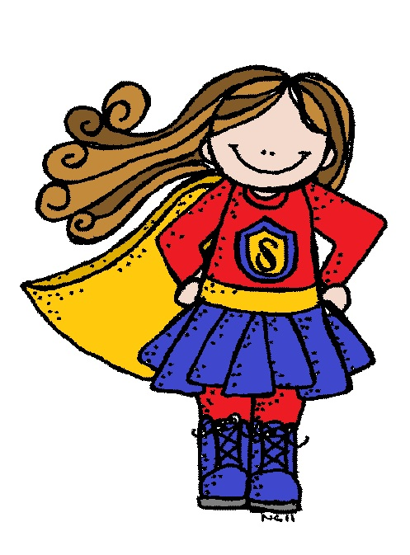 |  |  | DESCRIPTION  OF EACH ACTIVITY IS  ON THE BACK
3 | 4 | 5 | 6 | 7 | 8 | 9
 | Wellness  Center  Closed | Encaustic Art  9:00am-10:00am  Open Studio  10:00pm-11:00am | Parenting Girls Support Group  11:30am – 12:30pm  Kid’s Art Corner  3:30pm-5:00pm |  | 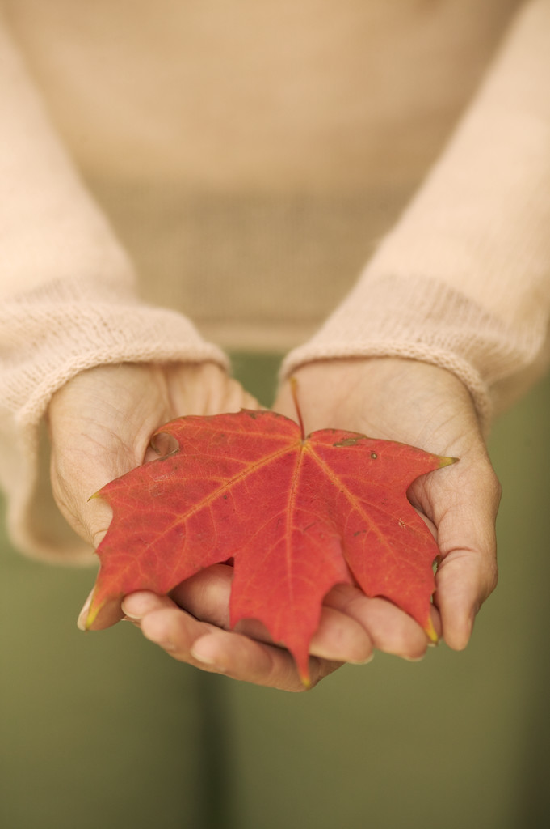
10 | 11 | 12 | 13 | 14 | 15 | 16
 | Encaustic Art  9:30am-10:30am  Open Studio  10:30am-12:00pm  For Women: Living with Less Stress  2:00pm-3:00pm | Open Studio  9:00am-10:00am  Knitting Circle  10:00pm-11:00am | Open Studio  9:30am-11:30am  Kid’s Heart Corner  3:30pm-5:00pm | 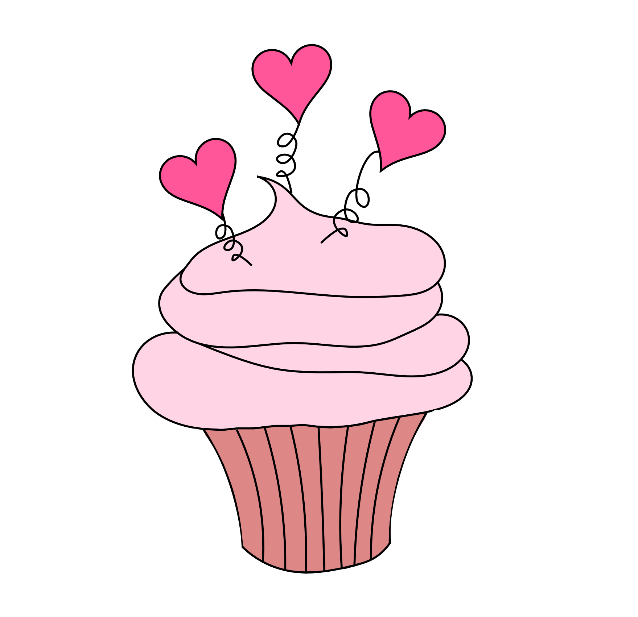 |  | 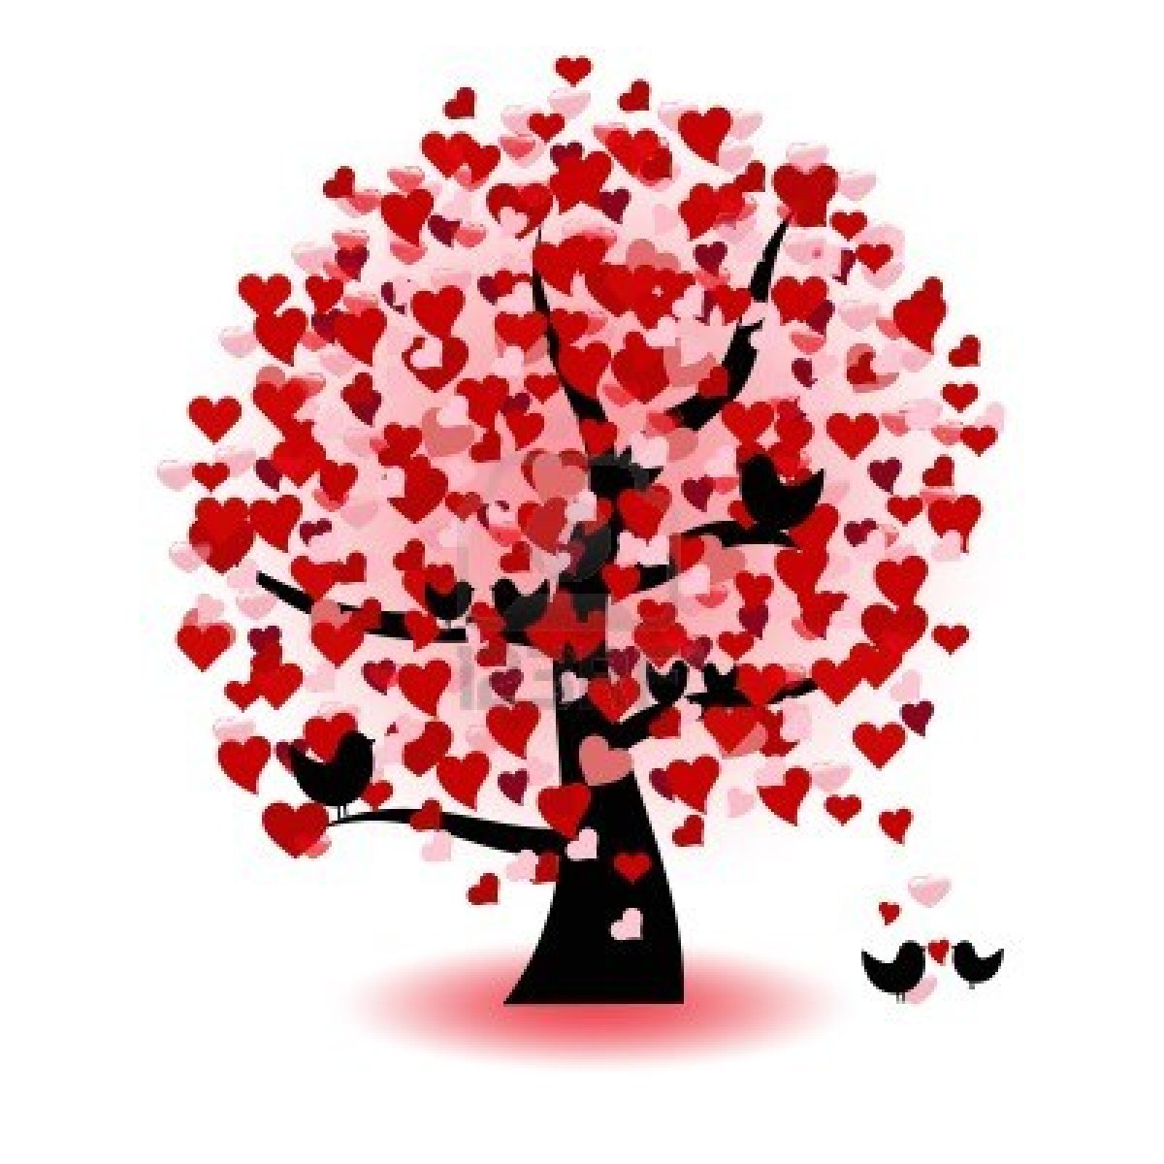
17 | 18 | 19 | 20 | 21 | 22 | 23
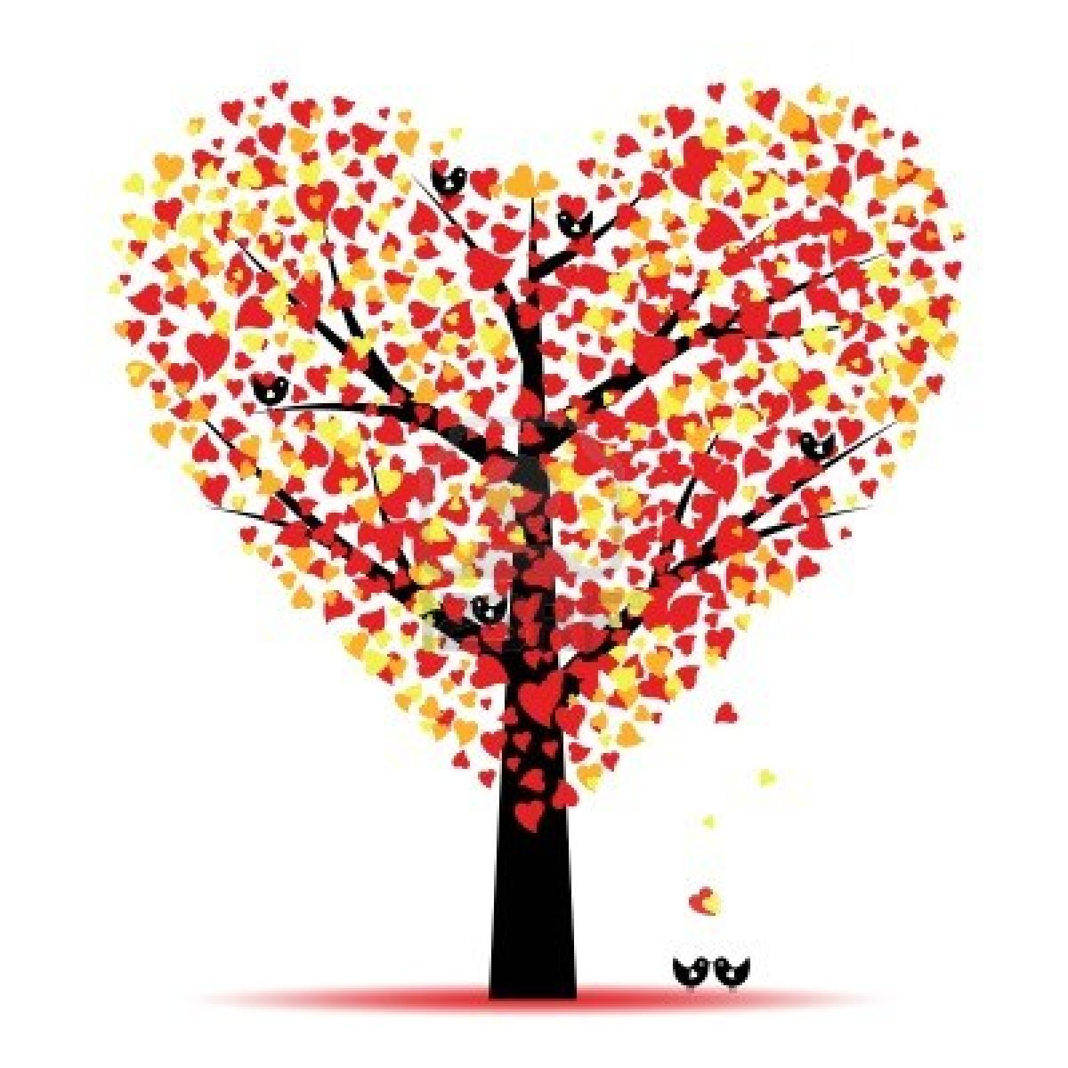 | Wellness Center  Closed  President’s  Day | Encaustic Art  9:00am-10:00am  Open Studio  10:00pm-11:00am | Open Studio  9:30am-11:30am  Parenting Girls Support Group  11:30am – 12:30pm  Kid’s Art Corner  Disney’s Brave  3:30pm-5:00pm
24 | 25 | 26 | 27 | 28
A service of Mono County Behavioral Health and Proposition 63. | Open Studio  9:30am-10:30am  Iris Folding Cards  10:30am-12:00pm  For Women: Living with Less Stress  2:00pm-3:00pm | Open Studio  9:00am-10:00am  Knitting Circle  10:00pm-11:00am | Open Studio  9:30am-11:30am  Parenting Girls Support Group  11:30am – 12:30pm  Kid’s Art Corner  3:30pm-5:00pm | 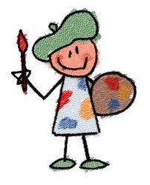 |  | 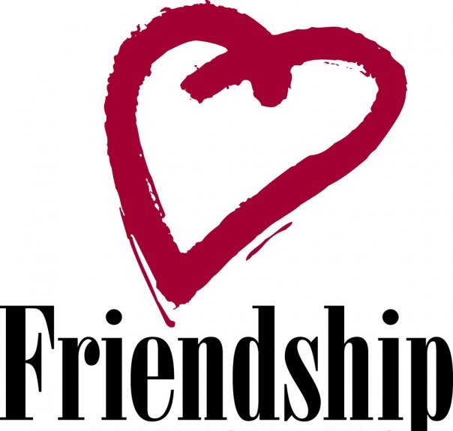
The Walker Wellness Center is located at 107655 Hwy. 395 (Just across the Hwy. from the Country Store) Feel free to call us at (530) 495-2363!!
A service of Mono County Mental Health and Proposition 63.

DESCRIPTON OF WELLNESS CENTER ACTIVITIES
KID’S ART CORNER: This activity is a perfect way to bond with your little one(s). For kids under 16, parents must be present to participate. We have a variety of arts and crafts for kids of all ages. On February 20th, we will be featuring; Brave – Disney’s movie about a courageous, Scottish Lass. Please join us!! Snacks to go with the movie will be provided!
KID’S HEART CORNER: This activity is for all ages. We will be working on everything hearts, from baking to painting! This is in honor of all of the people in our lives that have given us a piece of their heart and who have accepted a piece of ours.
Iris Folding Cards: Iris folding is a paper folding technique using colored papers. The folded strips of paper are layered in a spiral pattern. This technique is called iris folding because the center of the design is typically finished with holographic paper and the result resembles the iris of an eye or camera. The technique originated in Holland.

For Women: Living with Less Stress: Be able to talk about your life stressors in a safe environment. Learn various stress reduction exercises. Learn how to make choices in your life that give you the best results: caring for yourself. Learn from other women and share your life experiences to find out what stresses us and what we can do about it to maximize our happiness.
Knitting Circle: Calling all knitters! No matter what type of knitting you like to do, you will be welcome into the circle. All skill levels are encouraged to join us. Please bring any projects you want to share or any current pieces to work on. We have some knitting needles, looms and lots of yarn.

OPEN STUDIO: If you have a project you are working on, or if you want to learn a new craft, than this is the activity for you. This is a time to get together with others and share ideas and snacks.
Encaustic Art: Also known as hot wax painting. This Style of art is free and flowing. We use an iron looking tool to create original works of art. No two are the same. Have no fear, you can’t make a mistake.

PARENTING GIRLS SUPPORT GROUP: This group is for parents of girls from 5th grade up to high school age. Mothers and fathers are both welcome to attend to learn tools that may assist in raising your daughter to become a strong, confident and positive young lady. It is a great opportunity to share what has worked for you in specific instances and time for you to learn what the girls have shared in last years – Girl’s Empowering Change Group.

